John R. Meriwether
Professor of Physics
University of Louisiana—Lafayette

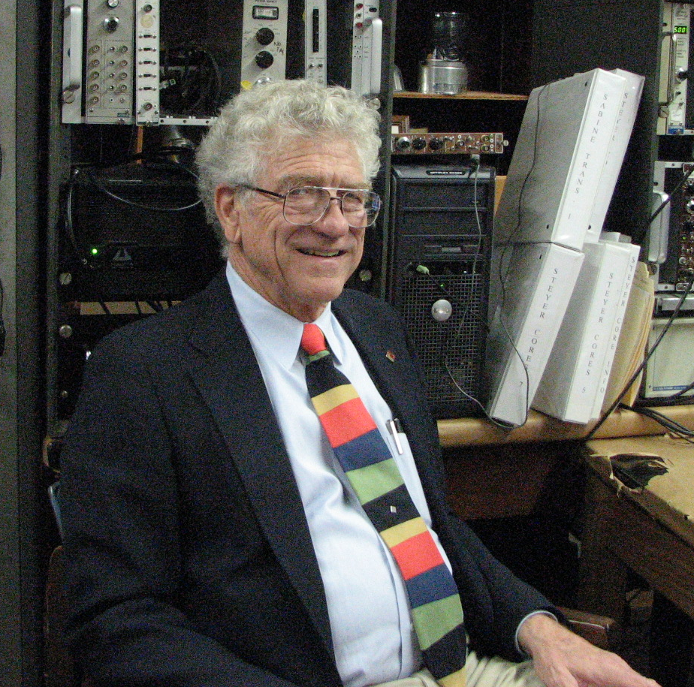

Dr John Meriwether has served in the Physics Department at the University of Louisiana—Lafayette for almost 43 years. He received his Bachelor of Science degree from Southwestern Louisiana Institute (now the University of Louisiana—Lafayette) in 1958 and his Doctor of Philosophy degree in Nuclear Science from Florida State University in 1962. His dissertation (Directed by Choppin and Fox):concerned Proton and Deuteron Induced Fission of 238U and 232Th. He served as a postdoctoral research associate at the University of California Berkeley with Bernard Harvey. His current research: involves radioactive dating to determine marsh land accretion.

